1. Account Registration Page

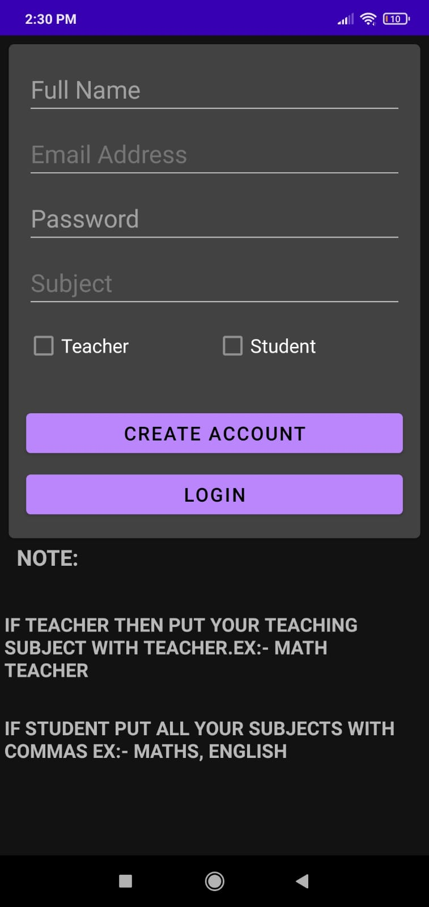

In this the user can create account as teacher and as student

## 2.Login Page

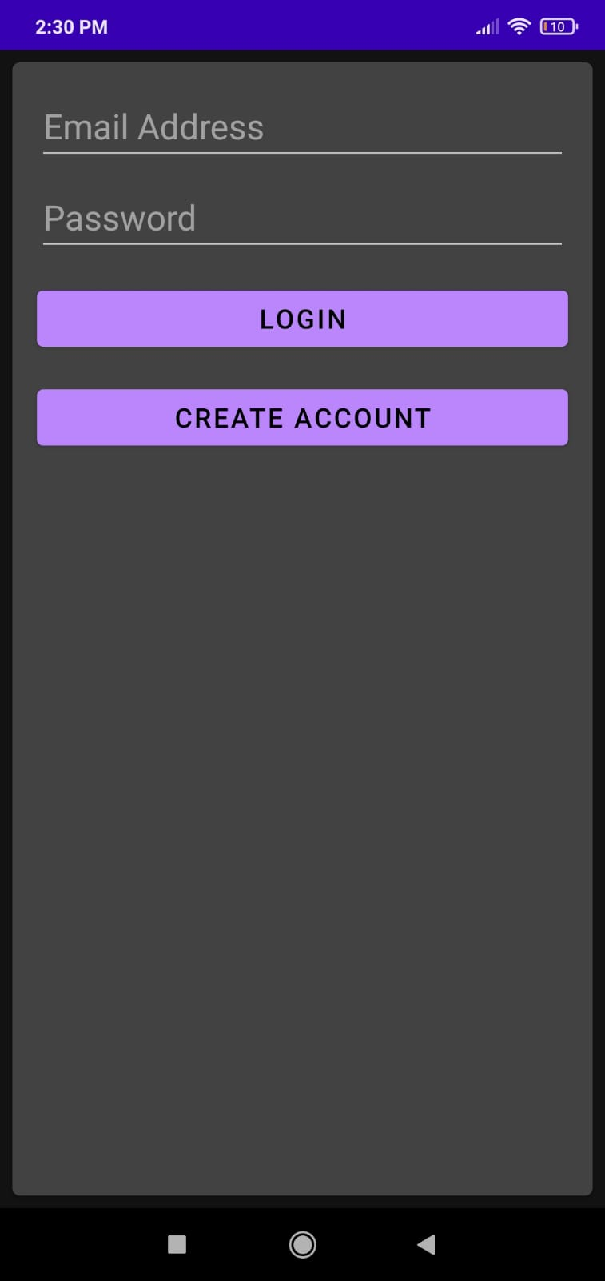

User can Login into there account on this simple interface page

## 3.Login as a Teacher(Admin)

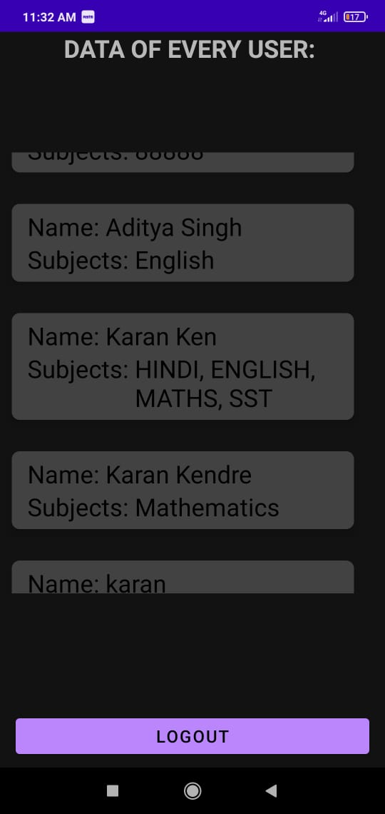

Here if the user has created his account as Teacher/Admin he has all the admin power

## 4.Login as a Student

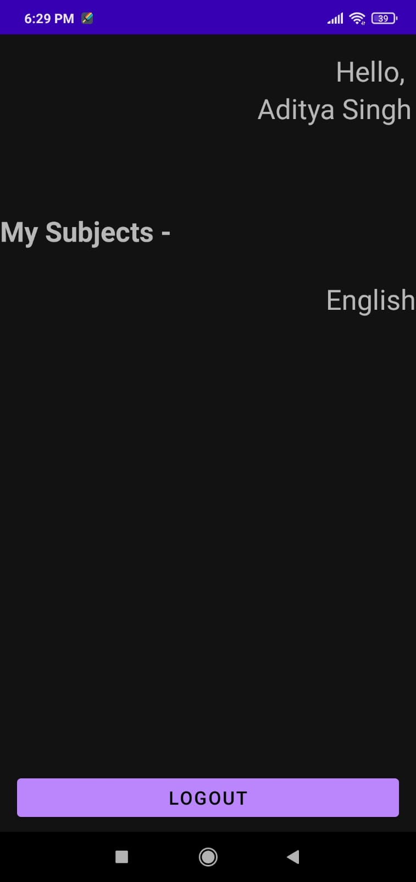

Here if the user has created his account as a student he can see all his subjects