|  |  |
| --- | --- |
| User documentation  EasySave V1.0 | Résumé  EasySave backup software user’s guide for the 1.0 version  Group 4  System programming project |

Table Of Contents

Presentation 2

Menu 2

Manage save templates 3

Create save templates 3

Delete save templates 4

Modify existing save templates 4

Execute one or more save templates 5

Execute one template 5

Execute all templates 5

# **Presentation**

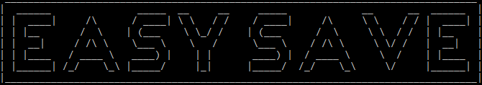

EasySave is a software which allow you to preconfigure up to 5 save templates and execute one or more (sequentially) when you want.

To use it, launch EasySave.exe which is going to open a command line interface where you will see the text above and a menu.

Read the steps described below to know how the software works.

# **Menu**

When opening the program, 4 options are available for the User. To reach the desired menu or pick an option, just press the matching number on the keyboard (Numpad keys work too).

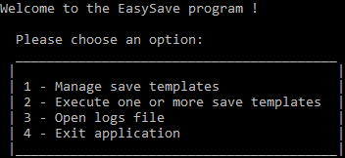

1. **Manage save templates**

*Opens the menu to create, delete or modify a save template.*

1. **Execute one or more save templates**

*Opens the menu to execute one or all save templates configured in the first menu.*

1. **Open logs file**

*Opens the today’s logs file.*

1. **Exit application**

*Closes the application.*

# **Manage save templates**

In this menu, 5 options are available. To select the desired one, press the matching number on the keyboard.

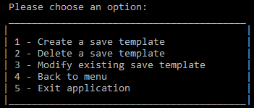

1. **Create a save template**

*Opens the menu to create a new save template, you can create a maximum of 5 save templates. If there is already 5 save templates, an error message will be displayed.*

1. **Delete a save template**

*Opens the menu to delete an existing save template. If there is no template configured, an error message will be displayed.*

1. **Modify existing save template**

*Opens the menu to modify the destination directory and / or the type of an existing save template. If there is no template configured, an error message will be displayed.*

1. **Back to Menu**

*Brings you back to the menu.*

1. **Exit application**

*Closes the application.*

## Create save templates

When you want to create a save template, a new menu appears.

1. **First, enter the name of your template, then press enter**.  
   Warning: don’t use the following characters “/":*?\<>|”
2. **Secondly, enter the source directory path then the destination directory path**. **Press enter after each.**Warning: the directories paths must respect usual path format and cannot be the same.
3. **Then, enter “1” if you want a full backup or “2” for a differential backup,** **then press enter.**

A message will be displayed if the information’s format is incorrect.



## Delete save templates

This menu appears when you want to delete an existing save template.

A list of your configurated template(s) will be displayed. Press the number of the template you want to delete, then press enter.

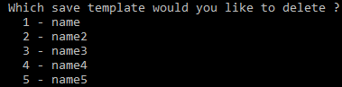

## Modify existing save templates

This menu appears when you want to modify an existing save template.

First, all the templates you have created before will appears. Press the number of the template you want to modify, then press enter.

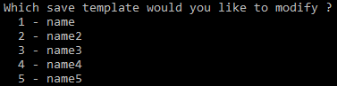

Then, enter the new destination directory path, or enter the same as before if you just want to modify the save type, then press enter.

Finally, change the save type by typing the right number. You can also enter the same type as before if you just want to modify the destination directory.

# **Execute one or more save templates**

When you want to execute one save template or all sequentially, a new menu appears with 3 available options.

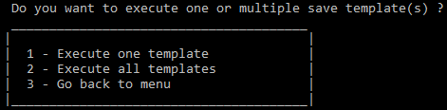

1. **Execute one template**

*Executes one specific save template you have created before.*

1. **Execute all templates**

*Executes all templates you have created one after the other.*

1. **Go back to menu**

*Brings you back to the menu.*

## Execute one template

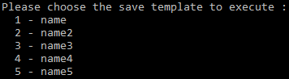

A list of your configurated save templates will be displayed. Select the number of the template you want to execute, press it on the keyboard, then press enter and the save will start.

## Execute all templates

A list of your configurated save templates will be displayed. If you really want to execute all templates sequentially (one after the other) press “y” or “Y”, otherwise press “n” or “N”, then press enter.

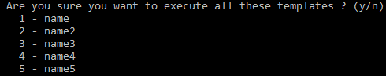

Warning: Before executing a differential save, you need to have done a full backup with the same source directory.