**Evaluation of modified IMOS-Toolbox bin-mapping code to process Nortek Signature ADCP data**

**Introduction**

The IMOS-Toolbox does not apply ‘bin mapping’ to Nortek Signature ADCPs to correct for instrument tilt.

Some code changes have been implemented in the IMOS-Toolbox to apply these corrections with the intent of processing the WAIMOS Signature data for upload to the AODN.

The transformation code for ENU to beam and beam to ENU was taken from Nortek’s script and then some lines were added to correct the beam values.

% Add a fourth line in the matrix based on Transformation matrix by

% copying line 3, and set (3,4) and (4,3) to 0. B3 and B4 will contribute

% equally to the X and Y components, so (1,3) and (1,4) = (1,3)/2. The

% same goes for (2,3) and (2,4)

% (1,1) (1,2) (1,3) (1,4)

% (2,1) (2,2) (2,3) (2,4)

% (3,1) (3,2) (3,3) (3,4)

% (4,1) (4,2) (4,3) (4,4)

% Make resulting transformation matrix

R1mat = zeros(4,4,row);

for i = 1:row

R1mat(1:3,1:3,i) = Hmat(:,:,i)*Pmat(:,:,i);

R1mat(4,1:4,i) = R1mat(3,1:4,i);

R1mat(1:4,4,i) = R1mat(1:4,3,i);

end

R1mat(3,4,:) = 0; R1mat(4,3,:) = 0;

% added to nortek code

R1mat(1,4,:) = R1mat(1,3,:)/2.0;

R1mat(1,3,:) = R1mat(1,3,:)/2.0;

R1mat(2,4,:) = R1mat(2,3,:)/2.0;

R1mat(2,3,:) = R1mat(2,3,:)/2.0;

To test the accuracy of the code and algorithms, data from a 4-beam Signature250 from deployment WATR20-2011 was processed using the Nortek processing software and comparison plots made.

**Results**

Beam1 data after conversion from ENU coordinates was the same as the Nortek beam1 data.

Velocity-north after bin-mapping showed a difference of up to 25% of the Nortek data. The larger differences occur at the higher velocities.

**Conclusion**

There is an issue with the bin-mapping process. The modified software requires troubleshooting to determine if the code or the algorithm needs changing.

**Beam1 after conversion from ENU coordinates**

The ENU data was converted to beam data using the Nortek software and the Toolbox software. The beam1 data from each software was plotted and the difference between the data sets was plotted.

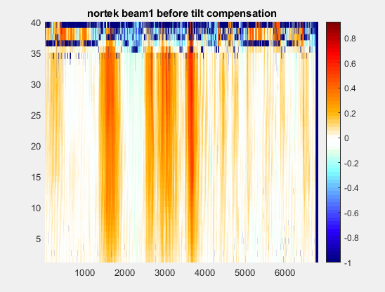

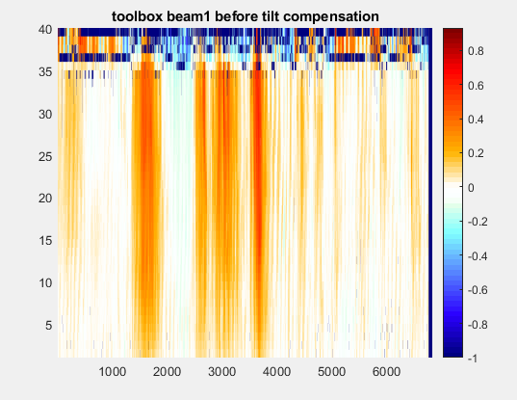

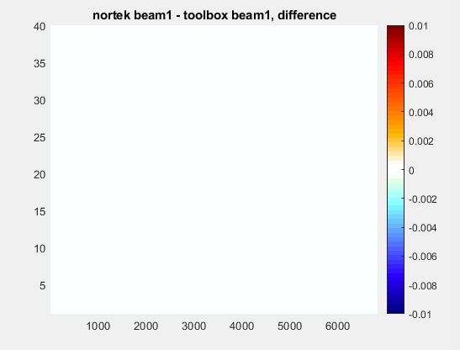

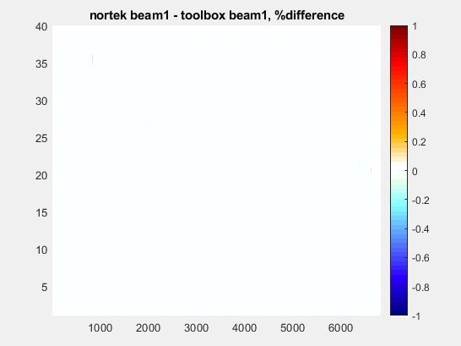

**Velocity north after correction for tilt / bin-mapping**

The raw data was processed for tilt correction in the Nortek software and bin-mapping in the Toolbox software.

The beam data was not available for export from the Nortek Software, so the velocity-north data was used.

The velocity-north data from each software and the difference between the data sets were plotted.

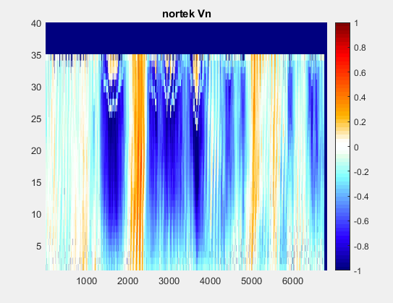

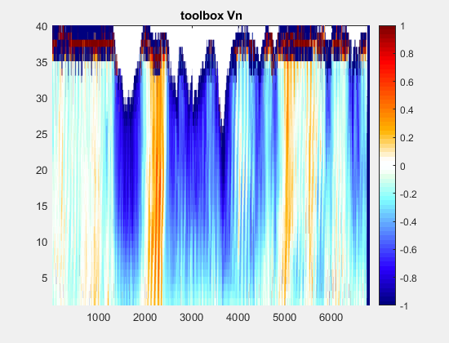

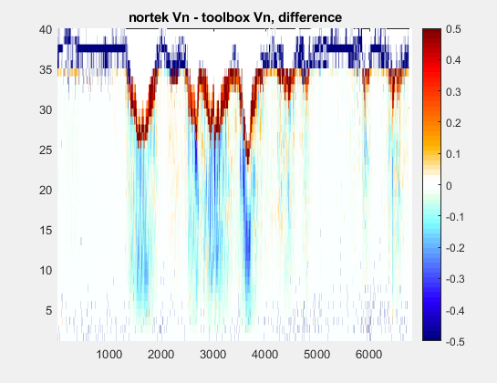

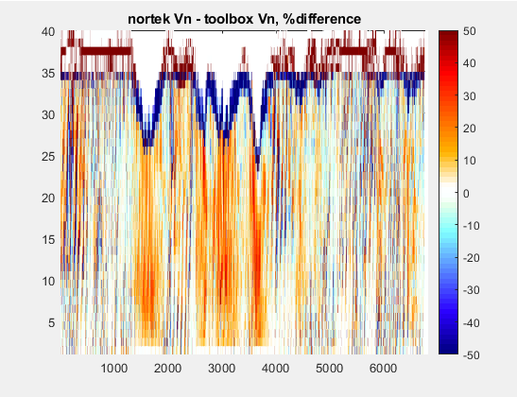

---ooOoo---