# Discharge upgrade Flows PR testing

These are the issues we’ve found when testing the edit flow:

1. Skipping questions
   * Tested on “**I received a discharge upgrade or correction, but my upgrade came in the form of a DD215 and I want an updated DD214”** flow
   * Example:
     + Review screen
     + Click Edit on Year Discharge
     + Change answer to 2009
     + Click Continue to Month Discharge
     + Don’t select an answer
     + Click Back to Year Discharge
     + Click Back to Service Branch
     + Click Continue takes you to Month Discharge, skipping over Year Discharge
   * [This is the mural flow example](https://app.mural.co/t/departmentofveteransaffairs9999/m/departmentofveteransaffairs9999/1696352911500/80253b1c7200212cbcbcfb940d2cf4a29fed8417?wid=0-1724857890163) for reference on how this flow should work.
   * This happens on multiple branching questions. When I hit edit on a branching question and I hit “Back” on 2 or more questions this seems to confuse the entire situation.
   * Ideally, no questions would be skipped. I should just be taken through the exact questions I went through. This will prevent confusion when navigating through the flow.
2. Continuing flow instead of going to review screen
   * Tested on Main Flow (answers below)
   * Example:
     + Review screen
     + Click Edit on Year Discharge
     + Change answer to 2009
     + Click Back to Service Branch
     + Don’t change answer
     + Click Continue to Year Discharge
     + Click Continue to Month Discharge
     + Click Continue goes to next question instead of review screen
   * [This is the mural flow example](https://app.mural.co/t/departmentofveteransaffairs9999/m/departmentofveteransaffairs9999/1696352911500/80253b1c7200212cbcbcfb940d2cf4a29fed8417?wid=0-1724857890163) for reference on how this flow should work.
   * Jordan was saying this wasn’t happening for her so this is perhaps not consistent. Jordan was going through the “**I received a discharge upgrade or correction, but my upgrade came in the form of a DD215 and I want an updated DD214”** flow when testing.
   * My original answers were:

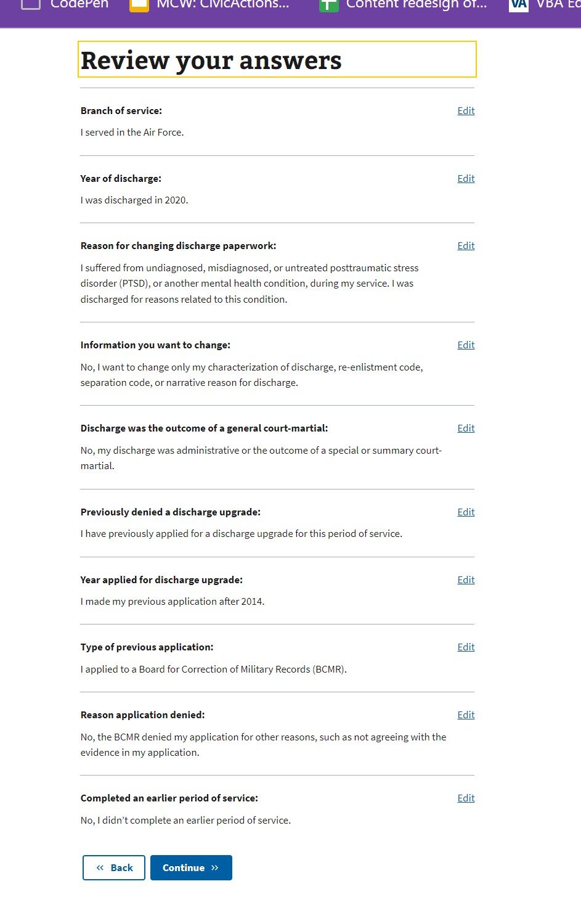

1. Prior Service question appearing again
   * Tested on “**My discharge is unjust, and this is not related to any of the reasons listed above”** flow
   * Example:
     + Review screen
     + Click Edit on Previous Application
     + Change answer from No to Yes
     + Click Continue to Previous Application Type
     + Answer “I applied to a Discharge Review Board (DRB) for a Documentary Review.”
     + Click Continue takes you to Prior Service. I would expect that this goes to the review screen.
   * I feel like I’ve had this explained to me before, but am asking again. This flow shows the Prior Service question no matter what answers are given. Ideally, it wouldn’t show again but is there a reason that it does?